PRESS RELEASE

COMMUNICATIONS AND MEDIA TEAM OF THE 2023 ASEAN SUMMIT

No.57/SP/TKM-ASEAN2023/ENG/5/2023

Indonesian President and Vietnamese PM Discuss Enhancing Trade and Investment Cooperation

West Manggarai, May 9 2023 – The President of the Republic of Indonesia, Joko Widodo, and the Prime Minister of Vietnam, Pham Minh Chinh, held a bilateral meeting at Hotel Meruorah, Labuan Bajo, West Manggarai Regency, East Nusa Tenggara Province, on Tuesday (9/5/2023). During the meeting, the two leaders discussed efforts to enhance bilateral trade cooperation.

"The two leaders discussed efforts to achieve a trade target of 15 billion US dollars by 2028," said Indonesian Minister for Foreign Affairs, Retno Marsudi, in her statement after accompanying President Joko Widodo in the bilateral meeting.

Minister Retno said that the two leaders were optimistic that the target could be achieved, "provided that all trade restrictions or barriers be reduced, if not completely eliminated."

President Joko Widodo and PM Pham Minh Chinh also agreed to immediately negotiate a bilateral investment treaty in line with the increasing investment from both countries.

"In addition, the two leaders also agreed to enhance cooperation in the field of renewable energy," she added.

On other issues, President Jokowi and the PM of Vietnam also agreed to immediately conclude the implementation and ratification process related to the completion of negotiations on the Exclusive Economic Zone (EEZ) of the two countries.

"Regarding the signing or the conclusion of negotiations on the EEZ between Indonesia and Vietnam which have been signed, the two leaders agreed that the implementing arrangement and ratification process should be completed soon. In addition, the President also conveyed that the MoU on marine and fisheries is to be resolved immediately," said the Minister.

Also accompanying the President in the bilateral meeting were Minister for Foreign Affairs Retno Marsudi, State Secretary Minister Pratikno, and State-Owned Enterprises Minister Erick Thohir. (Kemenlu/TR/Elvira)

***

For further information, please contact the following:

Director for Information and Media of the Ministry of Foreign Affairs – Hartyo Harkomoyo (0811831899).

Get more information at http://asean2023.id, https://infopublik.id/kategori/asean-2023, and https://indonesia.go.id/kategori/ragam-asean-2023

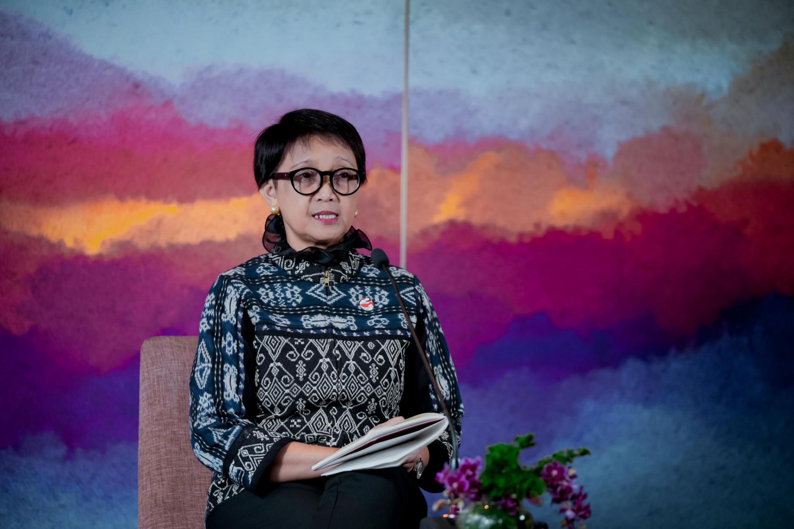

Minister for Foreign Affairs of the Republic of Indonesia, Retno Marsudi during her press statement after accompanying President Joko Widodo in a bilateral meeting between President Widodo and Vietnamese Prime Minister Pham Minh Chinh at Hotel Meruorah, Labuan Bajo, West Manggarai Regency, East Nusa Tenggara Province on Tuesday (9/5/2023). (Photo: BPMI-MoFA)

